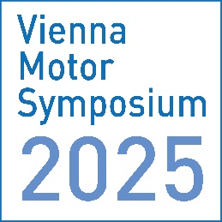

**LECTURE PROPOSAL**

**46th International Vienna Motor Symposium**

**14 – 16 May 2025, Hofburg Conference Centre Vienna**

* Please note that we can only accept papers which are **not published** before the date of the symposium in May 2025.
* Please upload the document as a PDF afterwards.

1) Please enter here the lecture title in English and (optional) German:

2) Please enter here the authors details:

Names of the author(s) as follows:

first name (abbr.), last name, company name, company location

3) Please enter here an abstract of 10–15 lines for general information:

Font: Arial

Font size for text: 11

Single line, justified